***Project Guidelines***

***Project = Face Recognition Attendance System***

***Class = 6B***

***Teacher = Sir Zahid Hussain***

***Subject = Artificial Intelligence***

***Group Members:***

***Inam Ullah CS191086***

***Faisal Zaman Haider CS182013***

***Poorab Gangwani CS191092***

***User Interface***

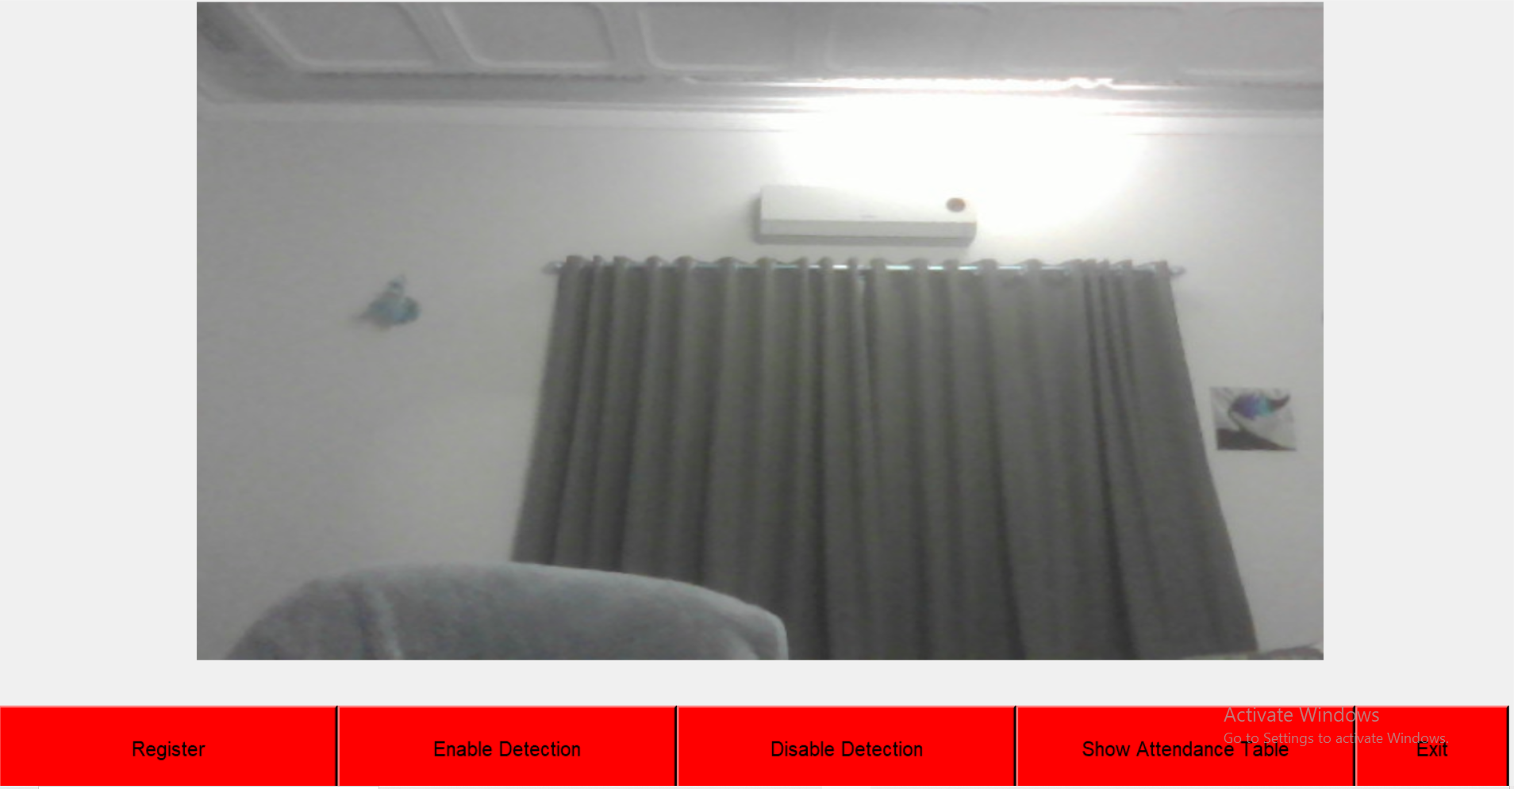

**Note:** Face must be closely approximated to the camera and properly adjusted and positioned

1. ***Register***

**It is the component which will register an unknown student face into the database along with name and roll-Number.**

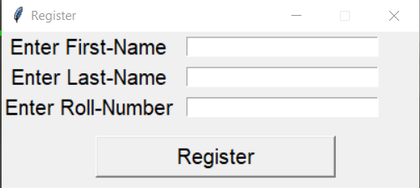

1. ***Enable Detection***

**It is the component which will enable face-detection and validation as a part of the database for marking of attendance**

1. ***Disable Detection***

**It is the component which will disable detection and validation of faces appearing on the screen. It will be the default mode when program is initialized.**

1. ***Show Attendance Table***

**It is the component which will display the marked attendance of students along with the day on which attendance was marked**

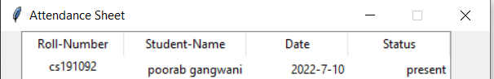

1. ***Exit***

**It is the component which will terminate the program**

**Steps for Face Detection and Recognition:**

1. **Start the program**
2. **Register your face and personal information into the database**

**2.1) Go to Register**



**2.2) Read the instructions carefully that appear beforehand and afterwards fill out the form**

**2.3) before pressing *Register* , make sure your face is appearing properly in the red box and your face is closely positioned to the camera for successful registration.**

**2.4) when registration is successful your face will appear in a green box (indicating that you are registered in the database and your database and your attendance will also be marked for the day)**

**OR**

**2.1) Enable Face Detection**

**2.2) if you are not registered then your face will appear in a red box and aurtomatically a message popup stating your non-existent registration and asking for you to register**

**Press OK.**

**2.3) fill out the registration form and before submitting it, make sure your face is in a red box and properly adjusted close to the camera otherwise registration will not be successfully submitted unless aforementioned requirements are satisfied.**

**2.4) Once successfully registered, your face will appear in a green box (indicating that you are registered in the database and your database and your attendance will also be marked for the day)**